Installing Intune Company Portal App on an Android Device

Introduction:
This document describes how to download and install the Company Portal (Intune) app on an Android device. Install the Company Portal app on your Android device to get access to Outlook email, contacts, calendar and work apps (Teams, OneDrive Excel, Power BI, etc.). The app allows you to securely access our company resources using your mobile device.

Prerequisites:
 Before using this document to install the Company Portal app on your Android device, you’ll need to do the following:
- Make sure your Android device is running on version 11.0 or later.
- Make sure your Android device has an unlock password set to a 6-character alphanumeric code which includes at least one special character.
  - To create or change your Android device unlock password go to: Settings → Lock Screen/Security → Password → Custom Alphanumeric.
- Make sure you know your Windows login password (used to log onto your Accu-Tech PC).
NOTE: You can follow these instructions while on WiFi or 4G LTE, however if you encounter an issue while installing over WiFi, please try following these instructions over 4G LTE.

Step: | Action:
1 | Locate the Google Play Store app on your device. (Not required if Company Portal is still installed)  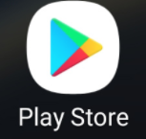  Open the Play Store app and search for the Intune Company Portal app. Then, click “Install.”  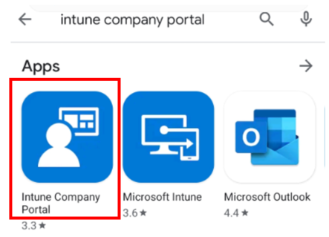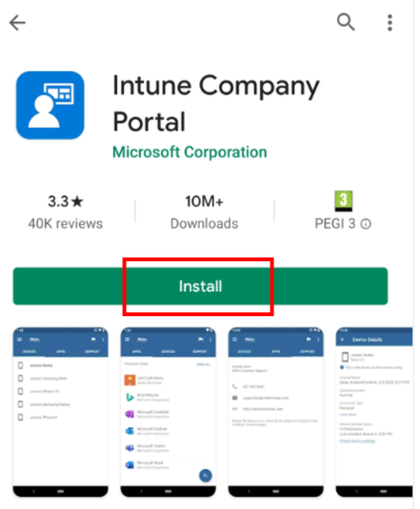
2 | Once the Company Portal app has installed, open the app and tap “Sign In.”  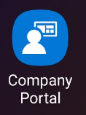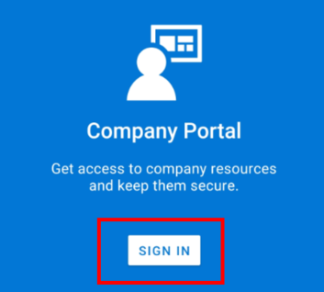  Next, sign in using your @Accu-Tech.com email address, and click “Next”.  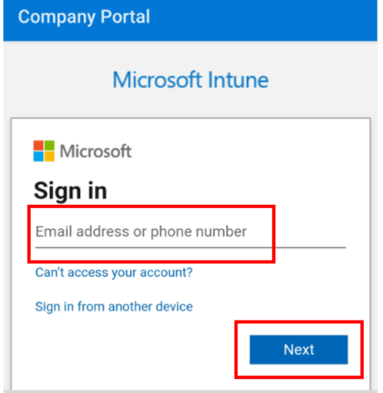
3 | - The “Signing into your account” screen will appear momentarily.  - Enter your Windows login password (used to log onto your PC each day). Then, click the “Sign in” button.  A B  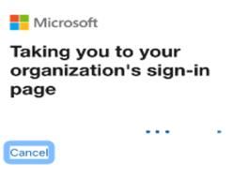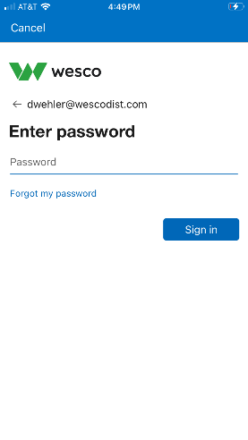
4 | You’ll get an MFA challenge prompt where you may need to enter the code from your Microsoft Authenticator App (see image below).  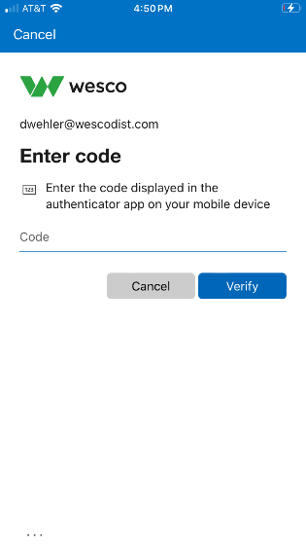
5 | - Enter the code and tap "Verify.”  - After MFA verification, a sign-in screen will then appear, which indicates that company resources are being loaded.  A B  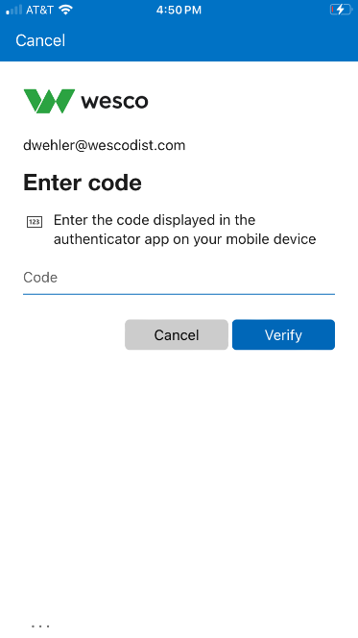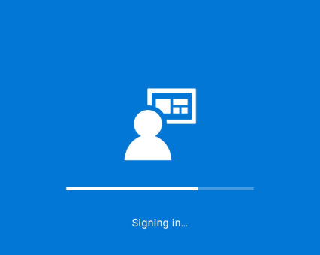
6 | The “Wescodist Access Setup” screen will appear. Click on the “Begin” button. (Do NOT click on the postpone button).  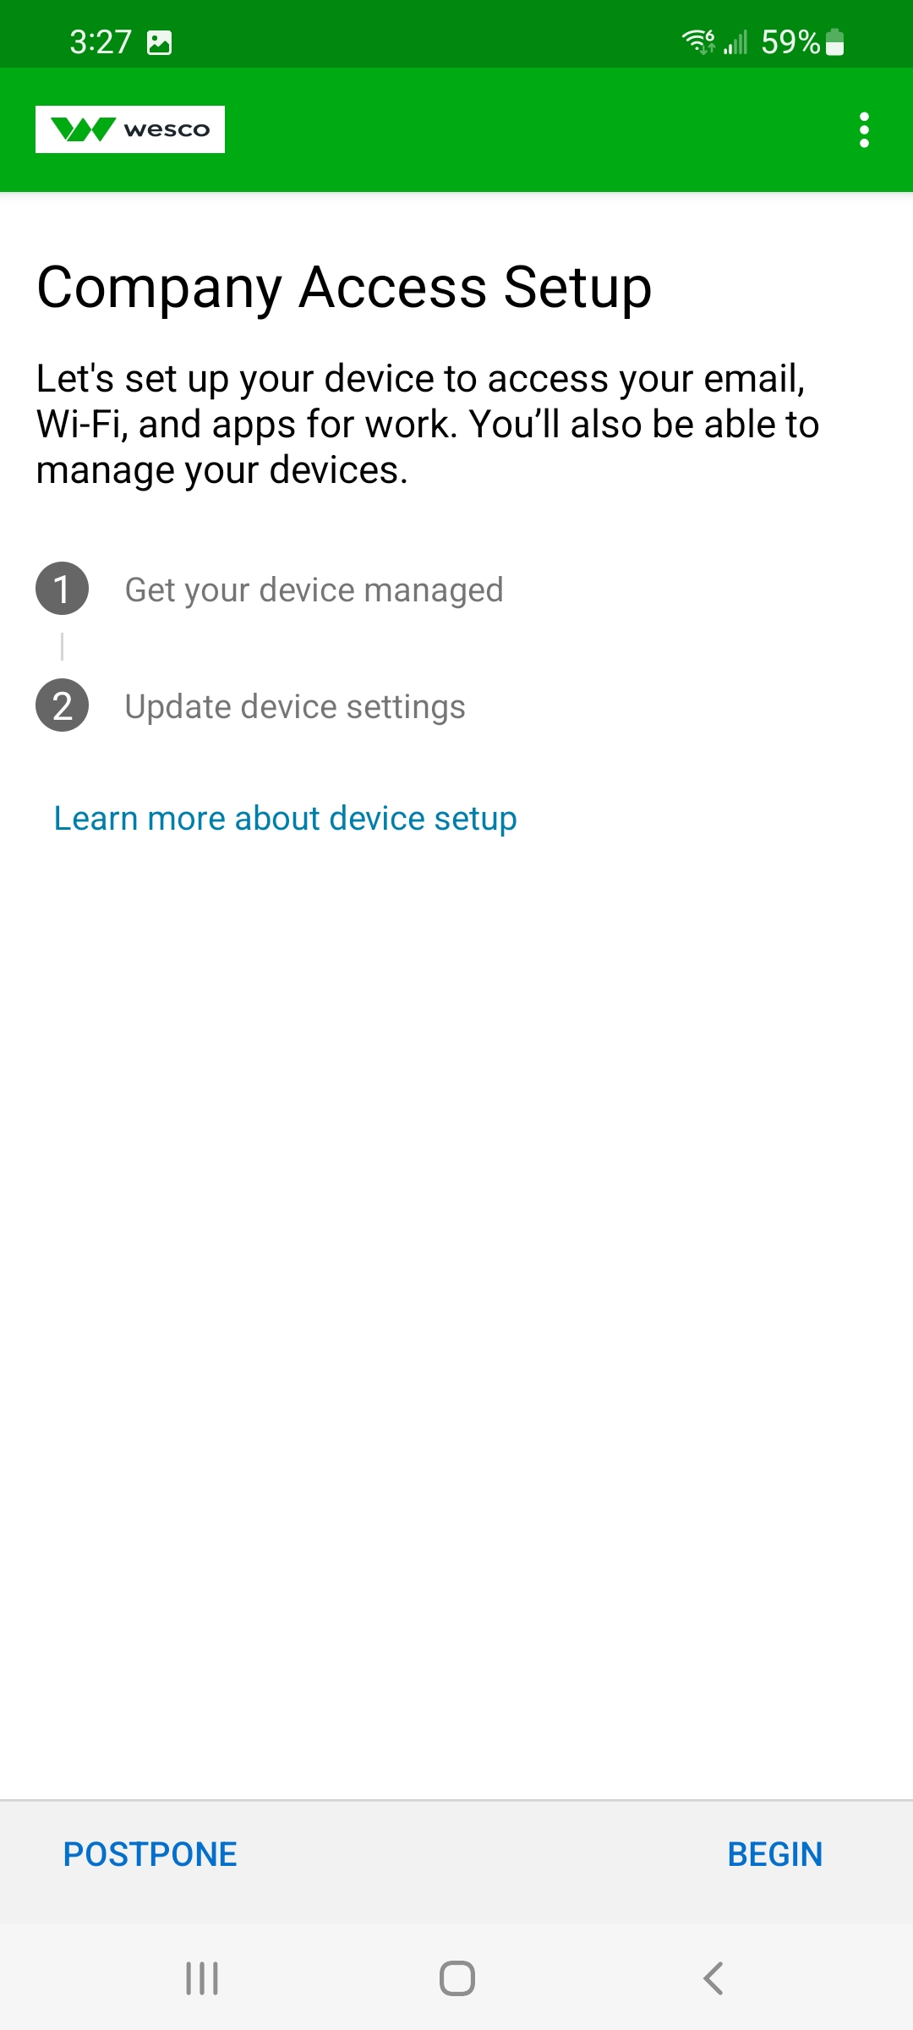
7 | - The “Wescodist Cares About Your Privacy” screen will appear. Review and then click on the “Continue” button.  - At the “What’s next?” screen, review and then click on the “Next” button.  - Click “Allow” on the “Allow Company Portal to make and manage phone calls message” and “Allow access to contacts.”  A B C  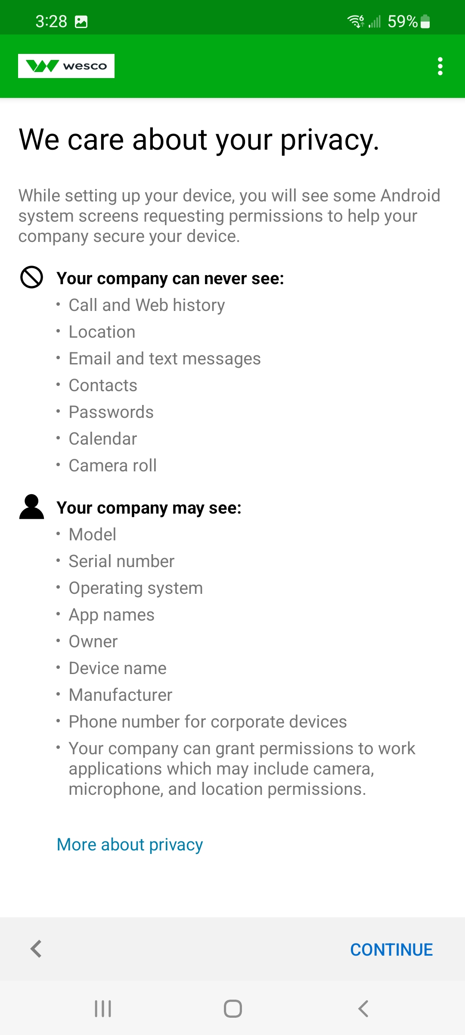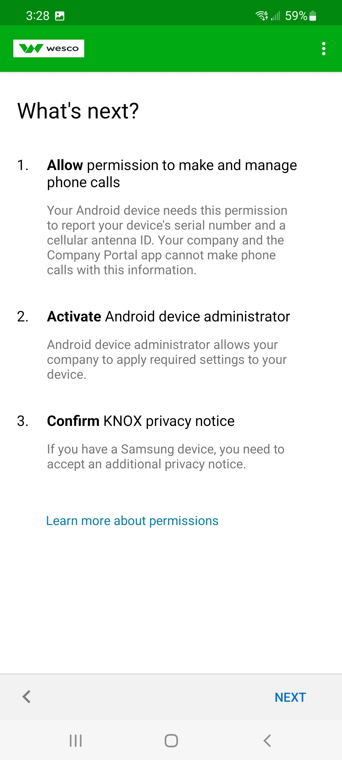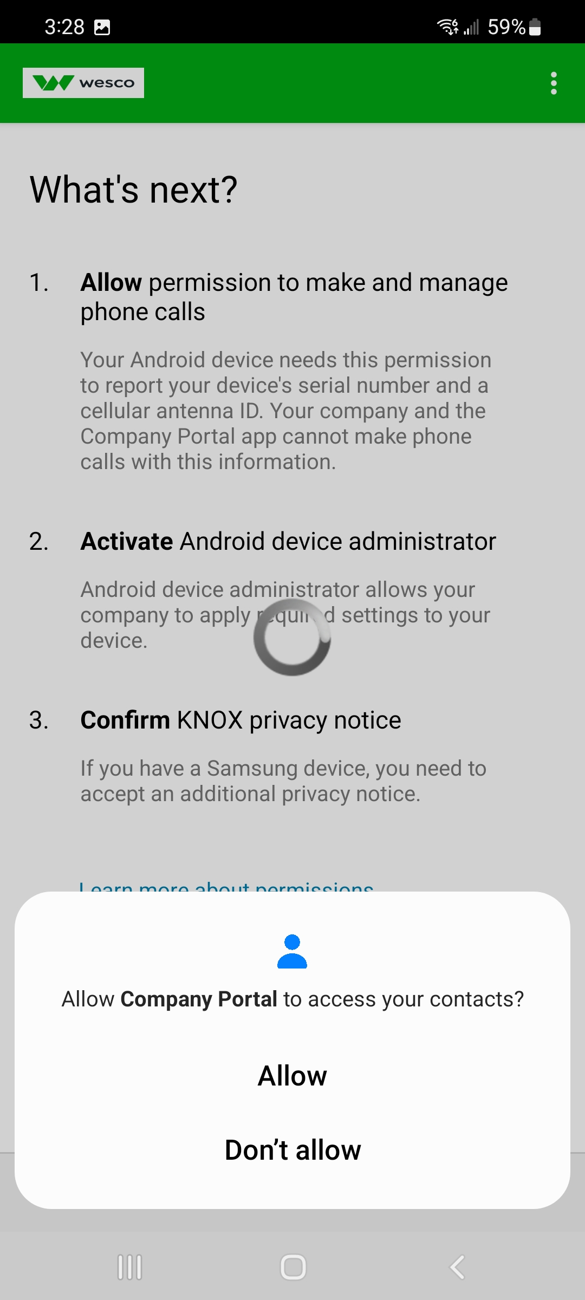
8 | - On the “Activate Device Admin app” screen, review and then click the “Activate” button.  - For Samsung devices, you will see “KLMS Agent- Samsung Knox” screen. Click the “Next” button.  - You will then see a “Finishing Setting Up Device” screen.  - Click the “Done” button on the “You’re All Set” screen.  A B  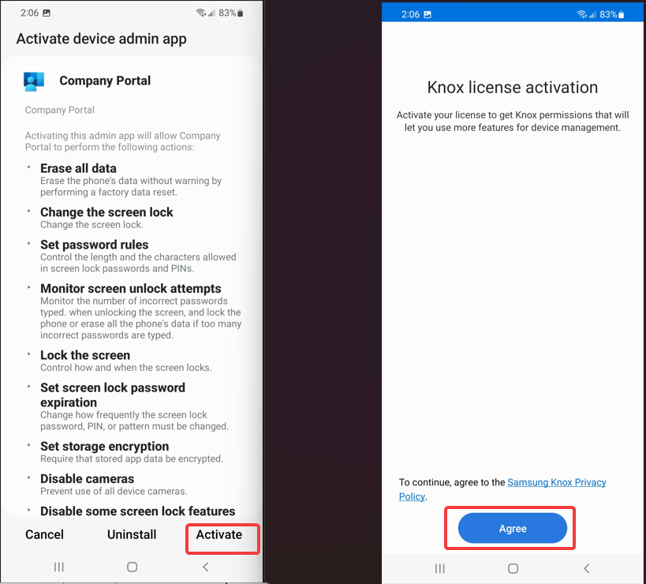  C D  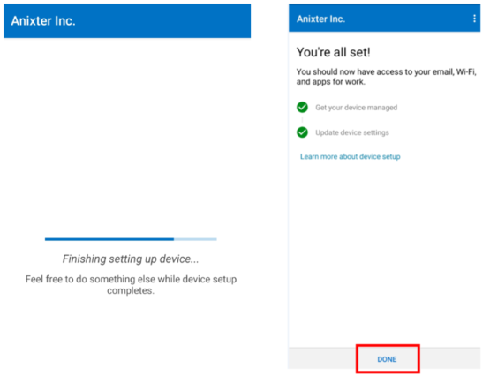
9 | Once setup is completed, you will be directed to the Company Portal app home screen. Click “View All” and then click “Microsoft Outlook.”  NOTE- if you already have the Outlook mobile app installed, you can move to step 11.  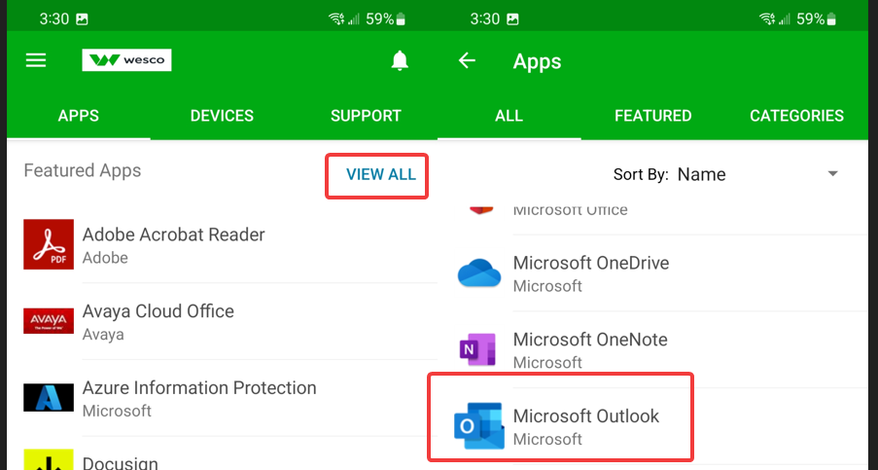
10 | - Click the “View In Google Play” button.  - You will then be directed to the Google Play Store. Click the “Install” button to install Microsoft Outlook onto your device.  - Once installed, click the “Open” button.  A B C  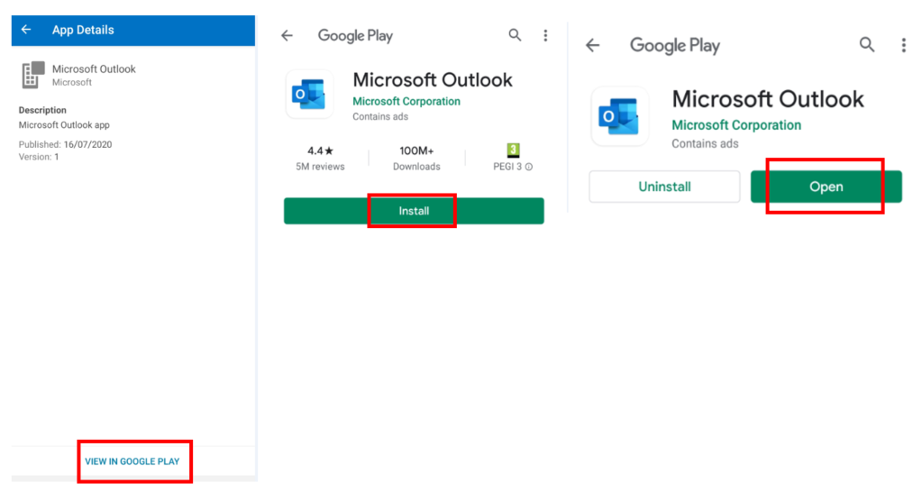
11 | - When the Outlook app opens, click “Get Started”.  - On the “Add Account” screen, enter your @Accu-Tech.com email address, and click the “Continue” button.  A B  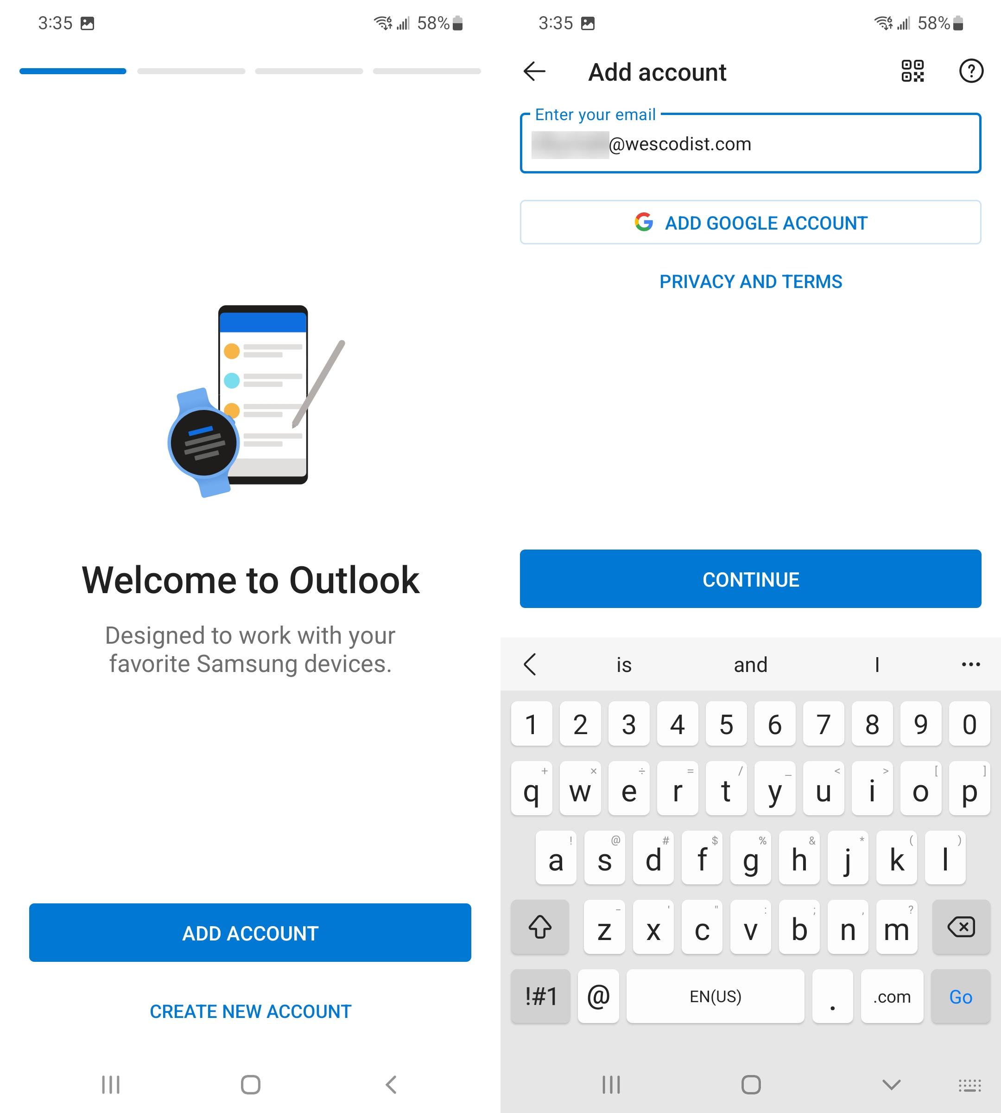
12 | - Click “Maybe Later” on the “add another account?” screen.  - Click the arrow on the “Focused Inbox” screen to review Outlook functionality.  - On the “Get Access” screen, click the “Continue” button.  A B C  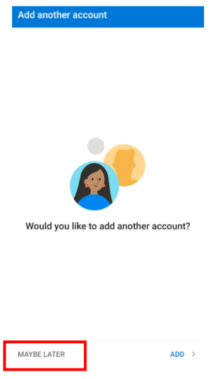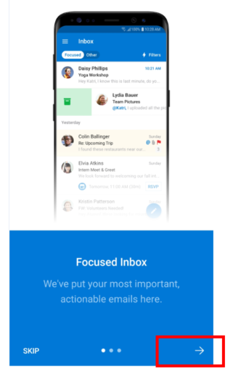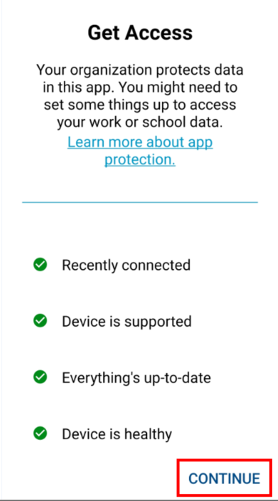
13 | - You should then see your Outlook inbox emails appear on the screen.  - On your Android device, check your notifications and tap on “Contact Sync”.  - On the “Allow Outlook to access your contacts?” prompt, tap “Allow” to sync your Accu-Tech contacts to your Android device.  A B C  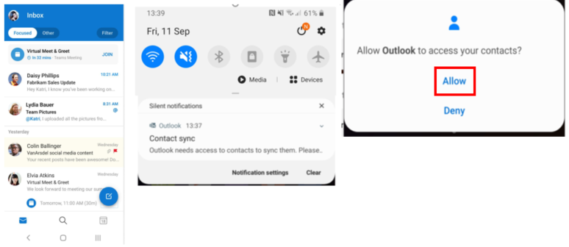
14 | To install Microsoft Teams and other company-managed apps, open the “Company Portal” app and tap “Apps” tab, and then tap “View All”. Here, you can install any of the available apps that you require for use.  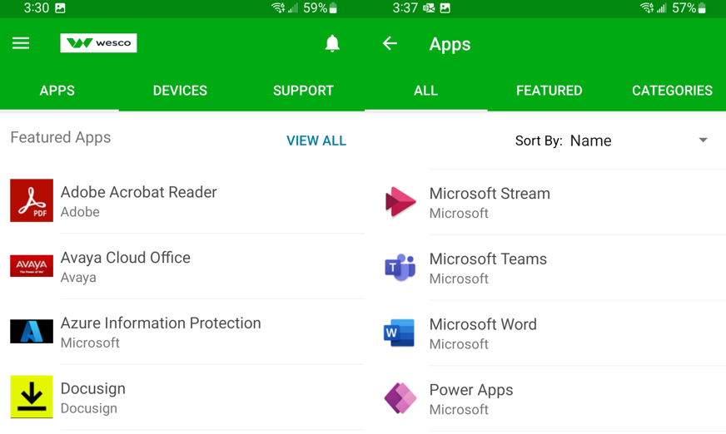  ***SETUP IS NOW COMPLETED***
Company Portal App FAQs
Q. Who do I contact if I have issues following this guide?
A. Please contact the Global Service Desk at 770-663-2020.
Q. How do I change my iOS device unlock passcode if I forget it or want it reset?
A. Please contact the Global Service Desk so that they can reset this for you.
Q. What happens if I enter the iOS device unlock passcode too many times?
A. After 10 incorrect passcode attempts, the device will erase back to factory default. For this reason, we recommend you call the Global Service Desk to have your iOS device passcode reset if you fail after a few times.
Q. How often do I have to change my iOS device unlock passcode?
A. Your iOS device will prompt you to change it every 90 days.

