Enrolling in Management Profile and Installing Intune Comp Portal App on an iOS Device

Introduction:
This document describes how to download and install the Comp Portal (Intune) app and set up a new management profile on your company-provided iOS device. You must install the Company Portal app on your iOS device to securely get access to your work apps (Outlook, Teams, etc.) and network.
Before you proceed with these instructions, make sure you know your iOS device’s passcode. You will need your passcode to successfully follow these instructions.

Prerequisites:
 Before using this document to install the Company Portal app on your iOS device, you’ll need to do the following:
- Make sure your Apple iOS device is running on version iOS 17.6 or later
- Make sure your iOS device has an unlock passcode set to a 6-character alphanumeric code which includes at least one special character
  - To create or change your iOS device unlock passcode, go to: Settings → Face ID / Touch ID and Passcode → Change Passcode → Passcode Options → Custom Alphanumeric Code
- Make sure you’ve followed the instructions to delete any existing Device Management profile already on the device. To do this, go to: Settings → General → Device Management. If there are any other profiles existing, delete them and restart your device.
- Make sure you know your Windows / Microsoft login password (used to log onto your PC)
- Make sure you know your Apple ID and password to access the Apple App Store
- NOTE: You can follow these instructions while on WiFi or 5G/4G Cellular; however, if you encounter an issue while installing over WiFi, please try following these instructions over Cellular

Step: | Action:
1 | Locate the App Store app on your device.    Then, open the App Store app and search for the Intune Company Portal app. Then, download the app.  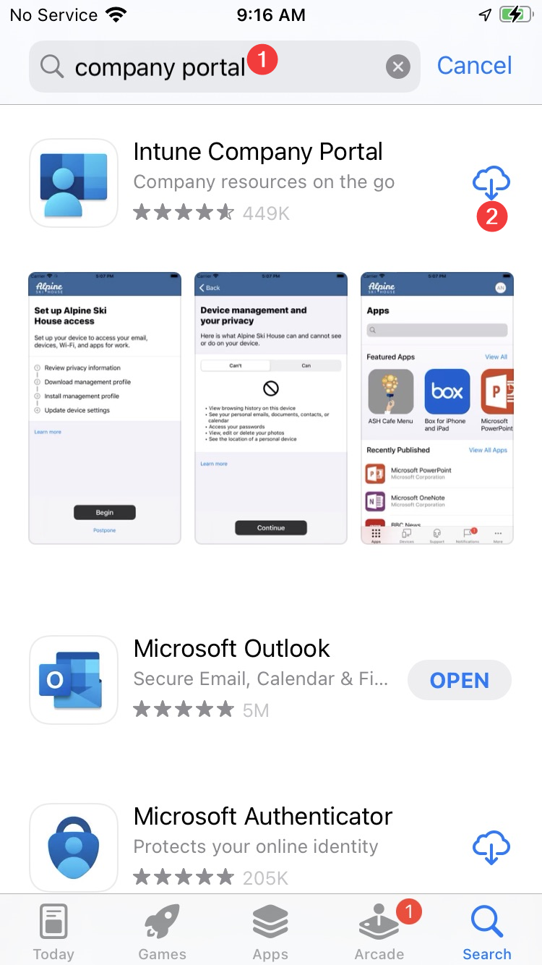
2 | Once the Comp Portal app has downloaded, open the app.  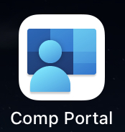  Next, sign in to your Microsoft using your @accu-tech email address. Then, click "Next.”  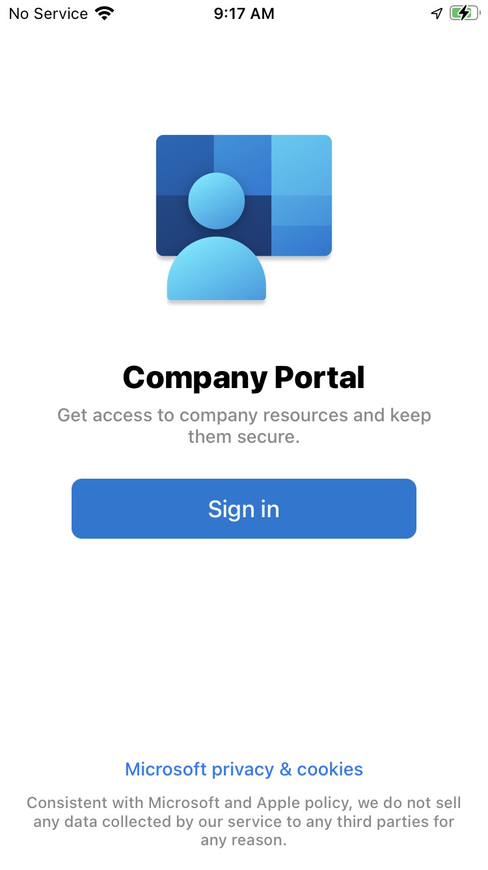
3 | - The “Signing into your account” screen will appear momentarily.  - Enter your Windows login password (the same password you use to log onto your PC each day).  - Click the “Sign in” button.  A B  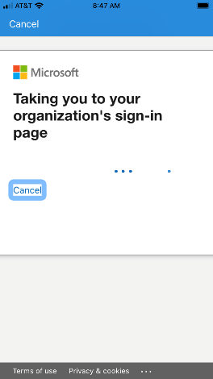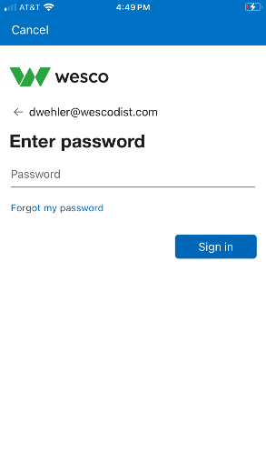
4 | You’ll get an MFA challenge prompt where you may need to enter the code from your Microsoft Authenticator App (see image below).  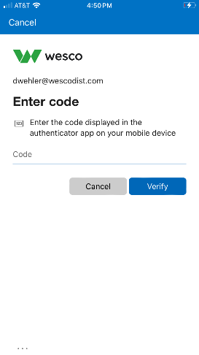
5 | A screen will appear that indicates that company resources are being loaded.  - When prompted to allow notifications, click “Ok”  - On the next screen, click “Allow”  A B  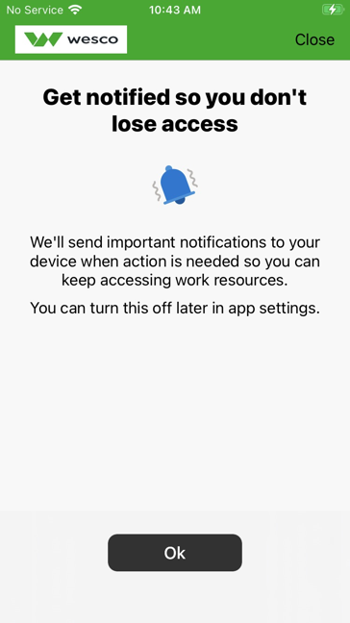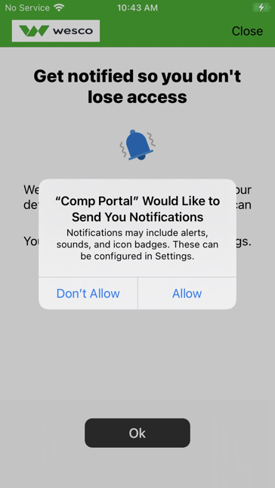
6 | The “Set up WESCO Inc. access” screen will appear. Click on “Begin” button. Do NOT click on the postpone link.  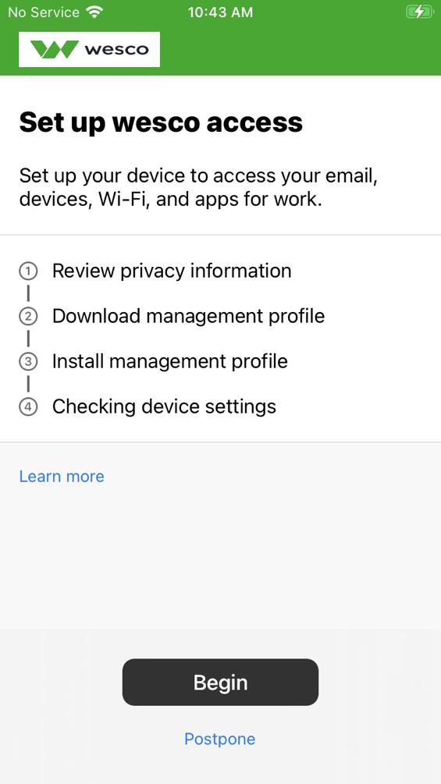
7 | - The “Device management and your privacy” screen will appear. Review the items under “Can’t” and “Can.” Then, click on the “Continue” button.  - You’ll then be back at the “Set up WESCO access” screen. Click the “Continue” button once more.
8 | - You’ll land on the “Download management profile” screen. Click on “Allow.”  - You’ll see a message appear stating “Profile Downloaded.” Click on “Close.”  A B  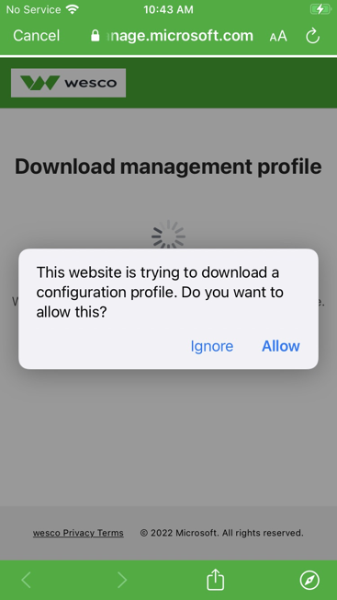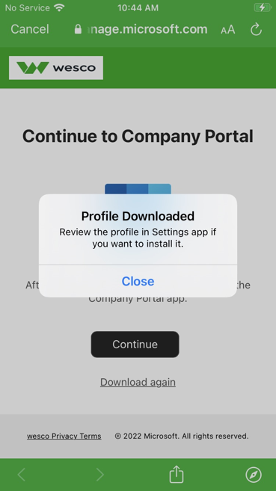
9 | Open the Settings app on your device.  
11 | - Tap on “General,” and scroll to “VPN & Device Management.” Then, tap on “Management Profile.”  - The “Install Profile” screen appears. Tap on “Install.”  A  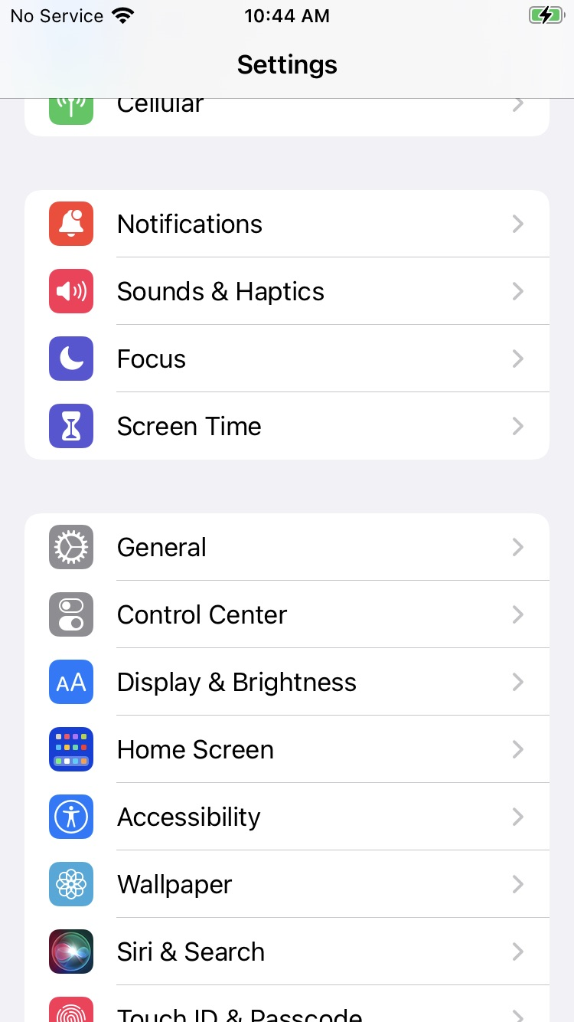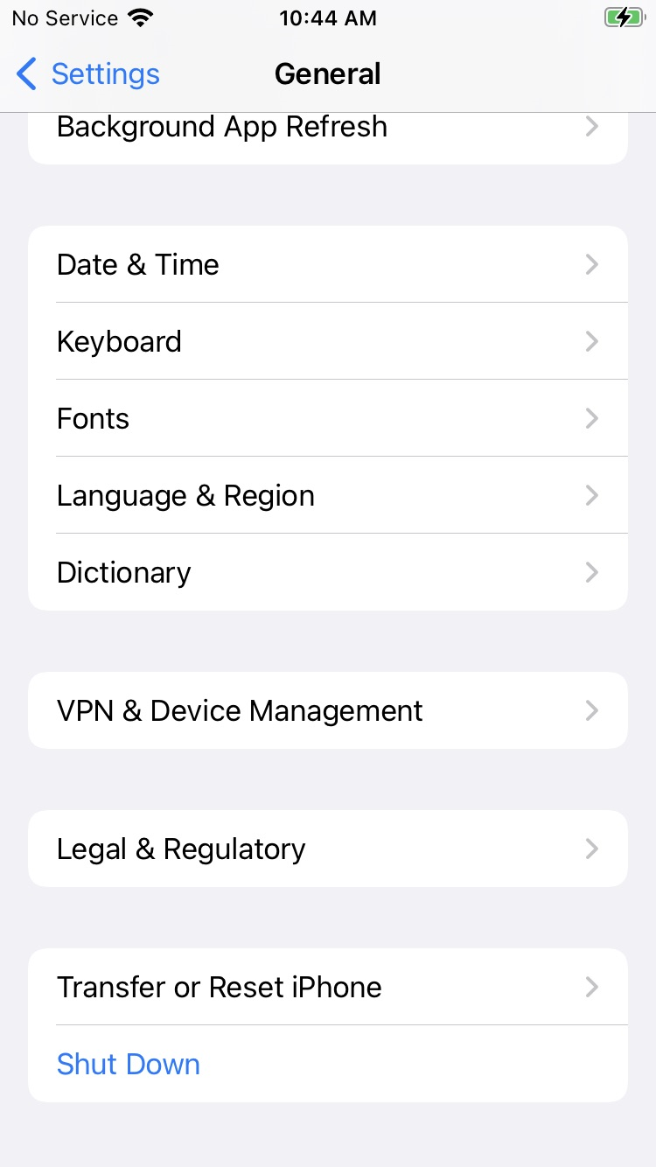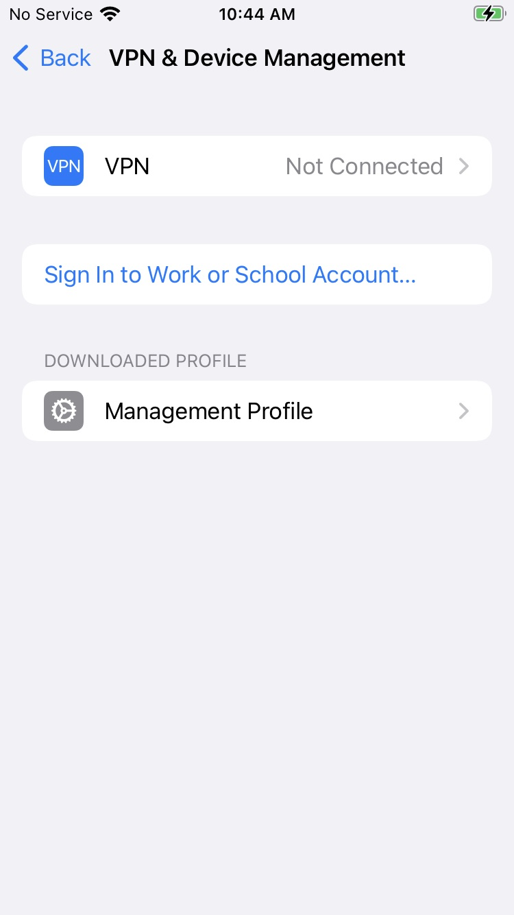  B  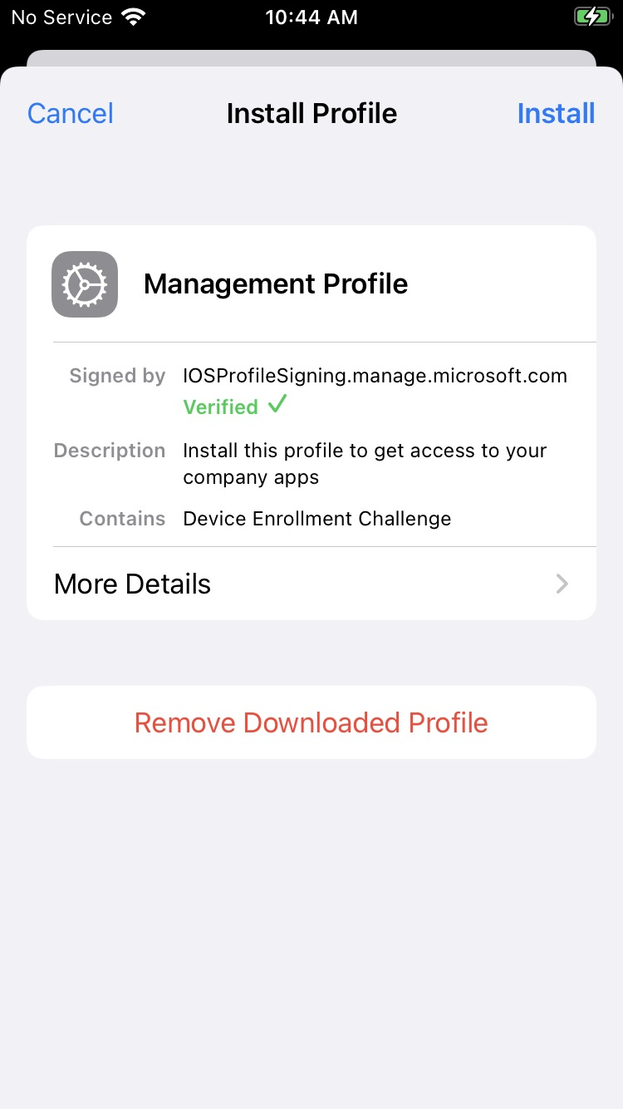
12 | - Enter your passcode (the code used to unlock your iOS device).  - Click on “Install” towards the bottom of the screen.  A B  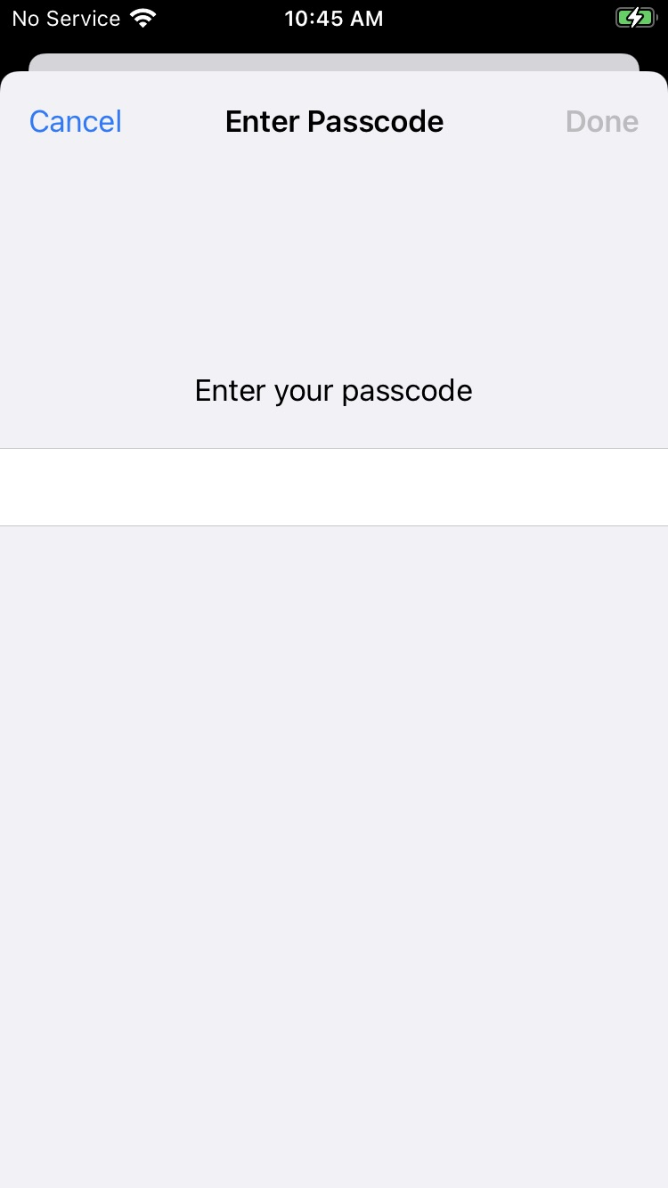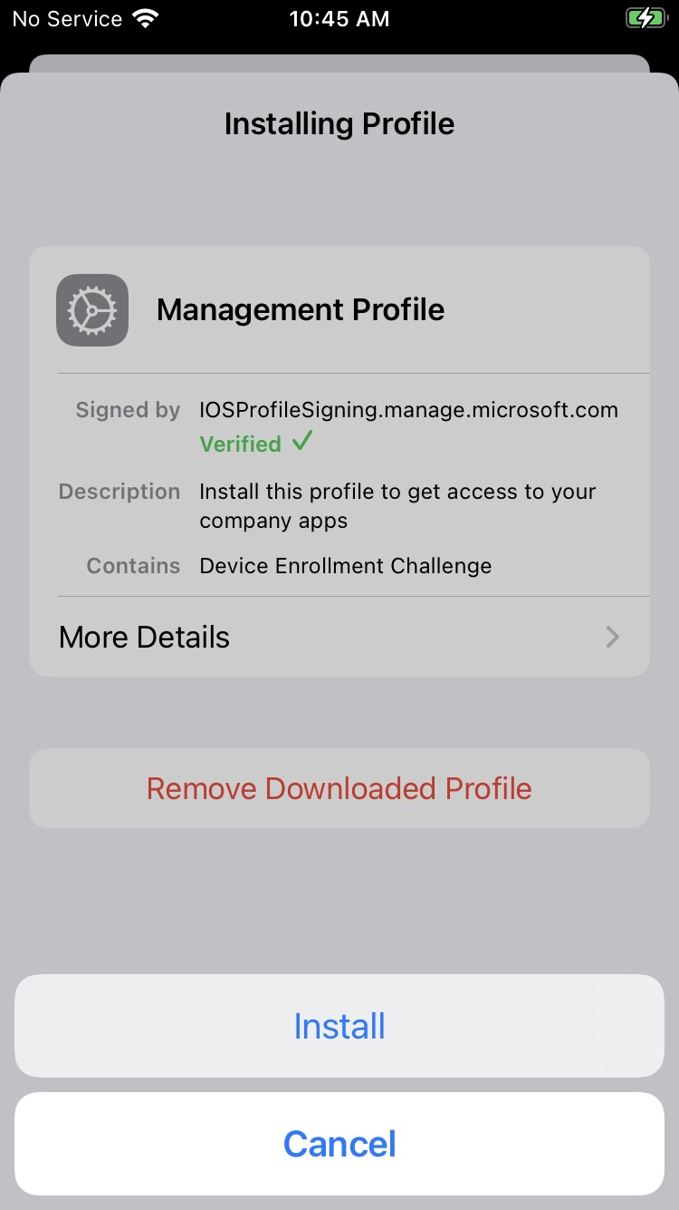
13 | - A “Warning” screen will appear. Read the information and then click on “Install.”  - A “Remote Management” box will appear. Click on “Trust.”  A B  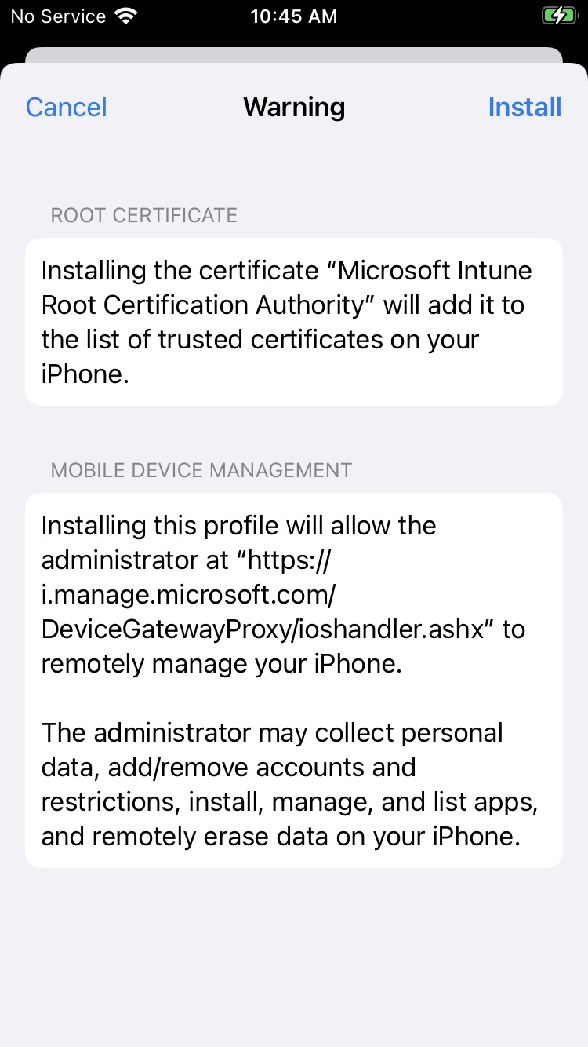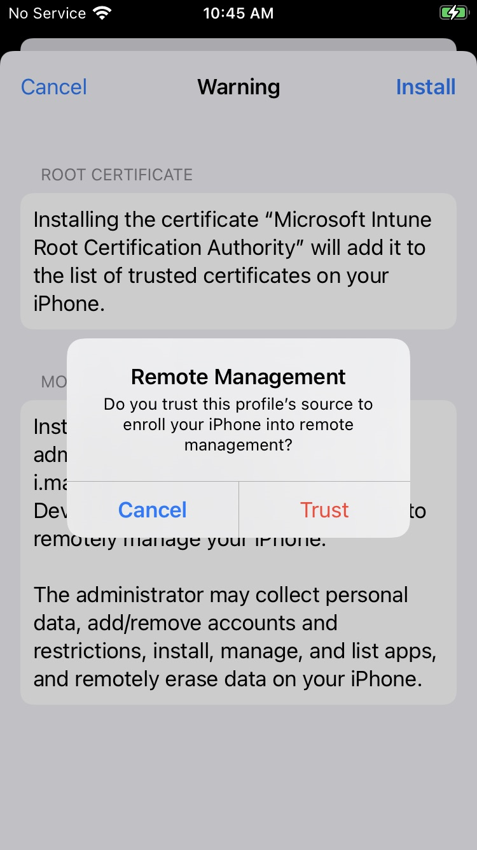
14 | - The “Management Profile” screen will appear, showing “Profile Installed” towards the top. Click on the “Done” button.  - Go back to the Comp Portal app on your device. Tap “Continue.”  - Now, the Install Management profile item will have a green checkmark next to it. Tap “Continue.”  - Intune will run a check for device compliance with company settings.  A B C  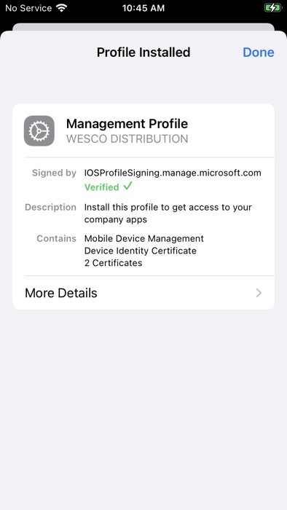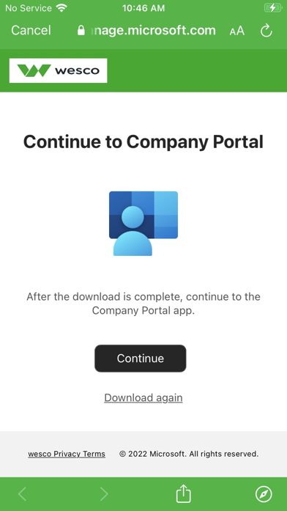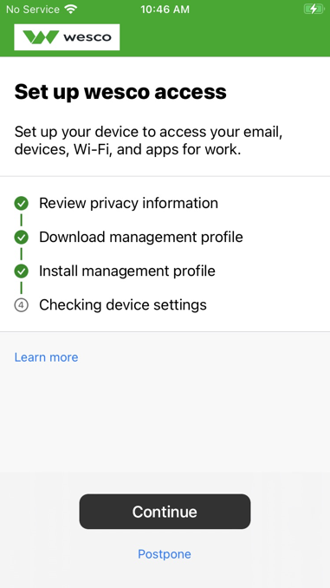  D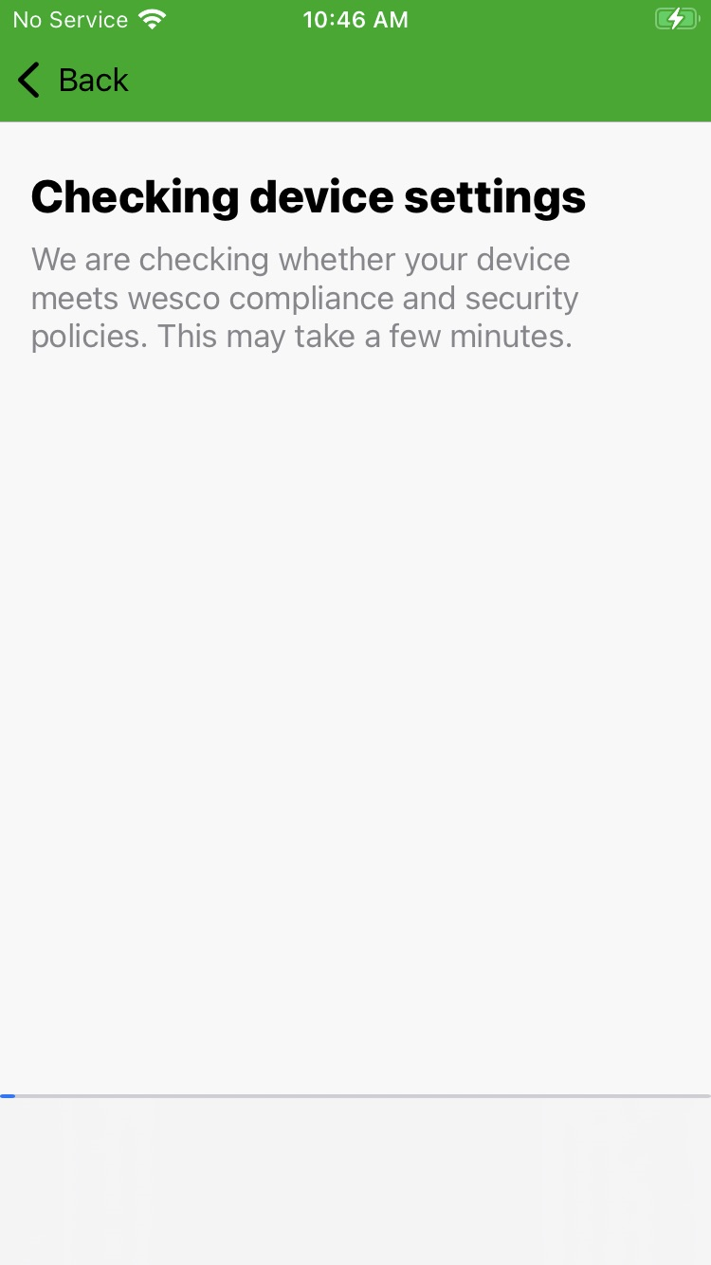
15 | NOTE: If your iOS device does not have an unlock passcode set to a 6-character alphanumeric code which includes at least one special character, you will be prompted to change it. DO NOT click “Later.” Follow the screens below to change it:  The new passcode must be a minimum of 6 characters, alphanumeric (numbers and letters) and must not contain ascending or descending characters (for example, “abc123”).  WARNING: If you do NOT get the ‘Passcode Requirement’ prompt box, please go back to your home screen. This should force the prompt box to appear. You can then update the passcode.  Once your passcode is updated, go back to the ‘Comp Portal’ app and move to step 16.  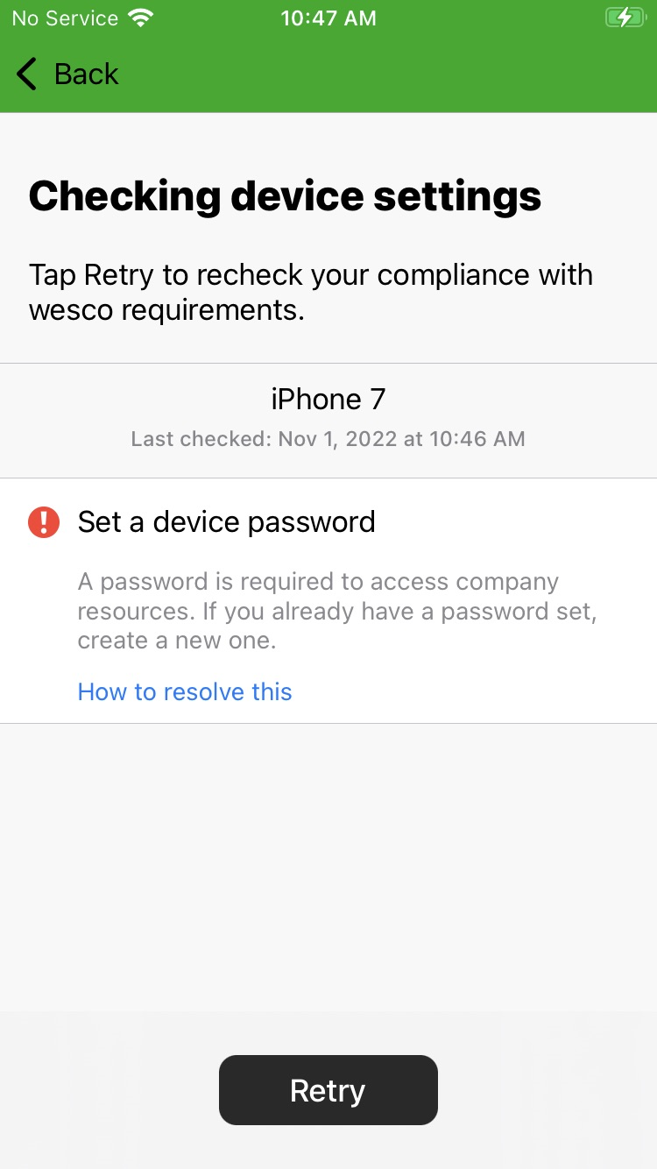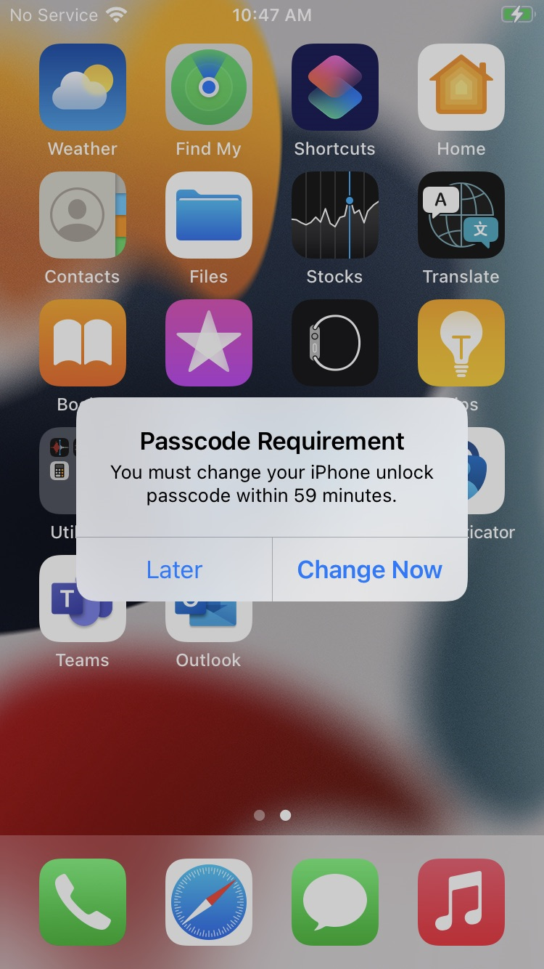  Enter your Current Passcode Enter a New Passcode Re-Enter Your New Passcode  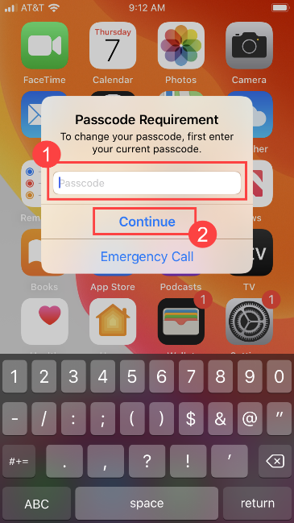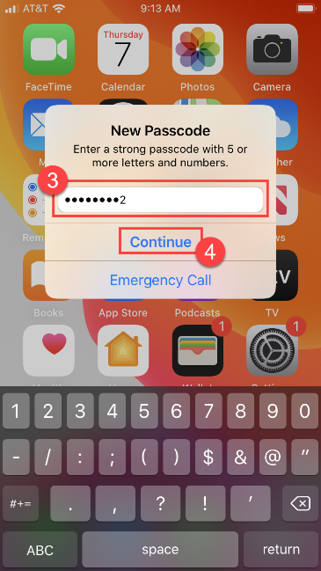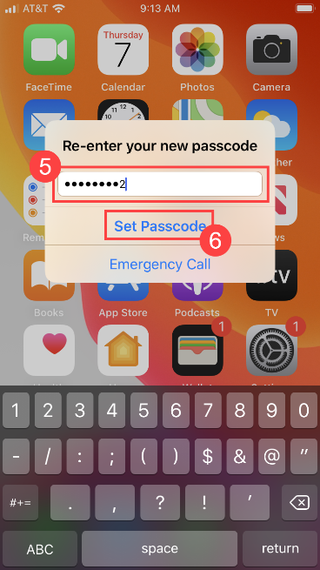  NOTE: In the future, if you need to change or reset your device unlock alphanumeric passcode, please contact the Global Service Desk.
16 | - Open the Comp Portal app once more. You should now see the “You’re all set!” text at the top of your screen as shown below.  A  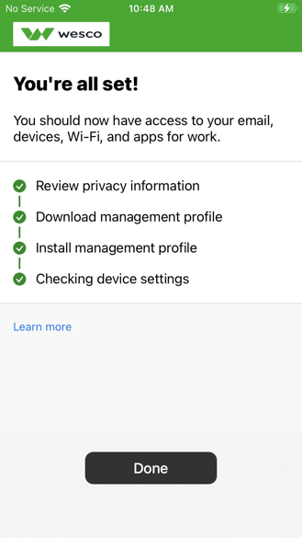
17 | Your Comp Portal app is set up and ready for use. If you would like to install the Microsoft Outlook app on your device (to manage your email, calendar, contacts, etc.), please proceed to step 18.  NOTE: If you already have the Outlook mobile app installed on your iOS device, please skip to step 21.
18 | - Open the Comp Portal app. From the Comp Portal app, tap “View All Apps,” search for Outlook and double-click on the “Microsoft Outlook” app.  - The “Microsoft Outlook” screen will appear. Click on the “Install” button.  A B  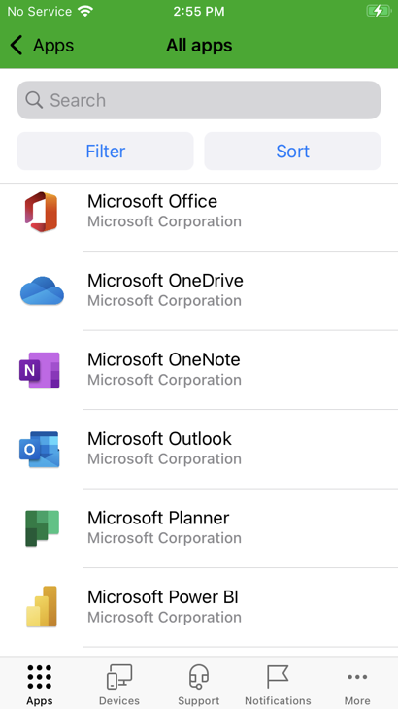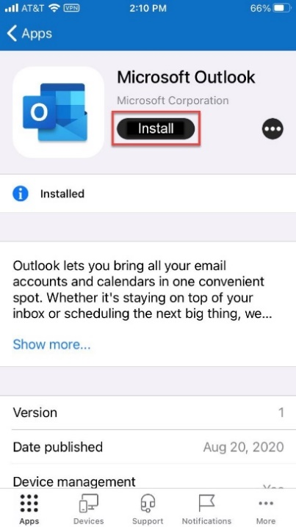
19 | - The app’s installation status will change to “Pending.”  - Moments later, an “App Installation” message will appear. Click on “Install.”  A B  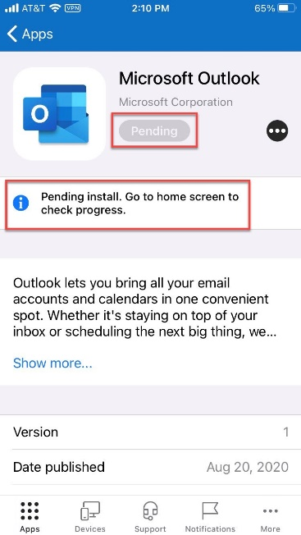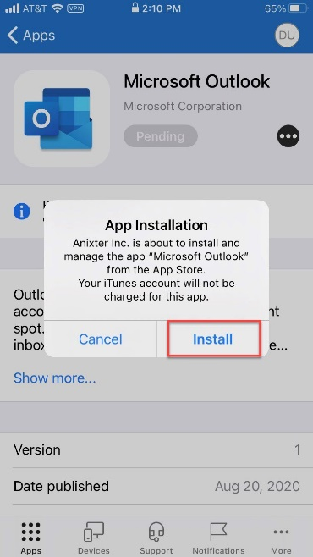
20 | The app will start installing.  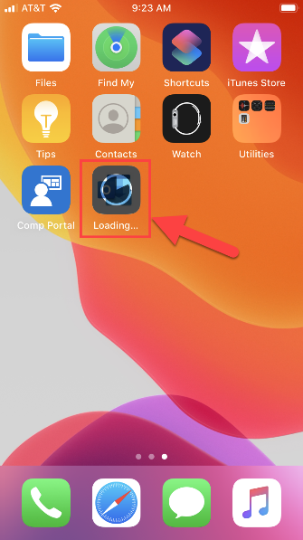
21 | - Open the Outlook app on your device. Your work email account should be listed. Click the “Add Account” button.  Note: If you already had the Outlook app installed, please look for your account in the “accounts” pane.  - A message will appear telling you that you need to restart the app. Click the “OK” button.  A B  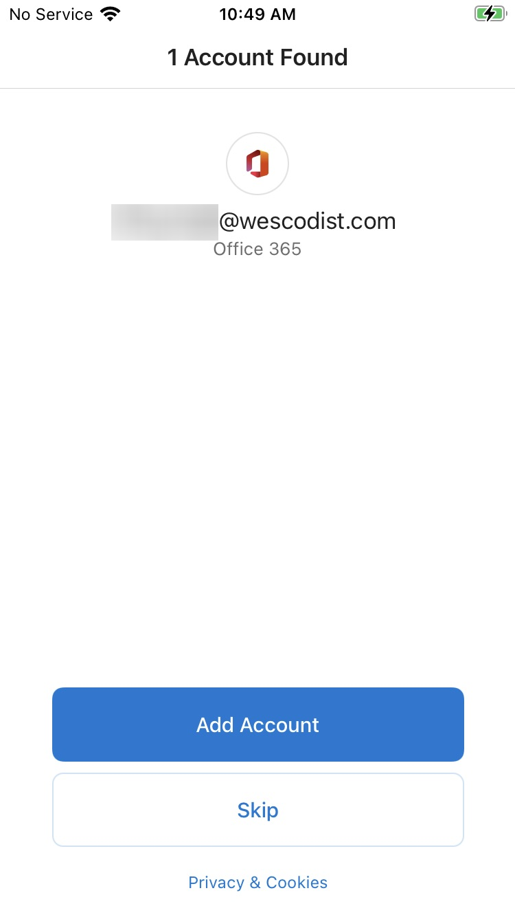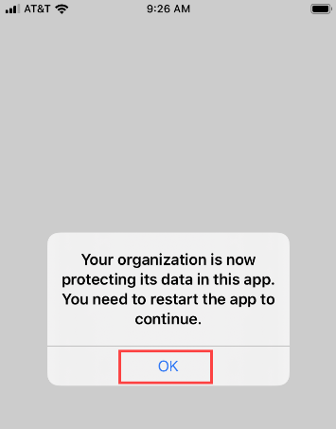  - The Outlook app will close. Go ahead and open the Outlook app once more. The following pop-ups will appear. Click “OK”, “Turn On,” and then “Allow” as shown below.  C  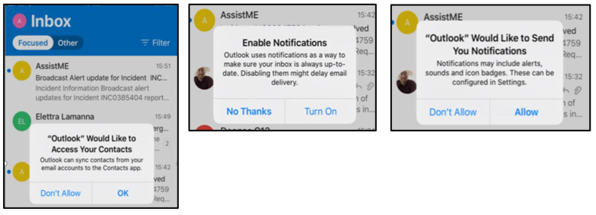
22 | If you already have Microsoft Teams installed on your phone: DELETE the app (UNINSTALL).
23 | - Open the Comp Portal app. From the Comp Portal app, tap “View All Apps,” search for Microsoft Teams and click on the “Microsoft Teams” app.  - The “Microsoft Teams” screen will appear. Click on the “Install” button.
24 | - Once Teams is downloaded on your device, you can login with your O365 login and password.

Comp Portal App FAQs
Q. Who do I contact if I have issues following this guide?
A. Please contact the Global Service Desk at 770-663-2020.
Q. How do I change my iOS device unlock passcode if I forget it or want it reset?
A. Please contact the Global Service Desk so that they can reset this for you.
Q. What happens if I enter the iOS device unlock passcode too many times?
A. After 10 incorrect passcode attempts, the device will erase back to factory default. For this reason, we recommend you call the Global Service Desk to have your iOS device passcode reset if you fail after a few times.
Q. How often do I have to change my iOS device unlock passcode?
A. Your iOS device will prompt you to change it every 90 days.

